BCCTM 2015-16 Math Competition Solutions

Grade 6/Pre-Algebra 7 Individual

- C
- A
- C
- B
- A
- D
- B
- C
- B
- D
- B
- A
- D
- C
- B
- A
- B
- D
- C
- B
- C
- C
- C
- A
- C
- C
- B
- A
- A
- E

Grade 6/Pre-Algebra 7 Individual Solutions

#28
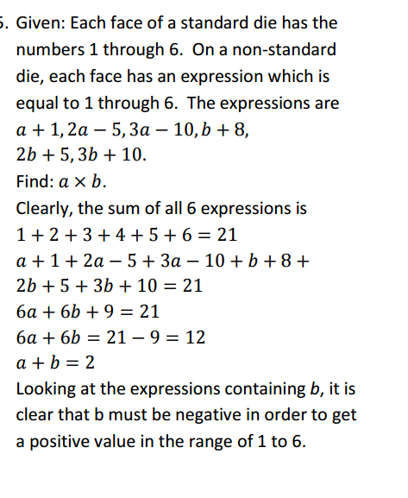
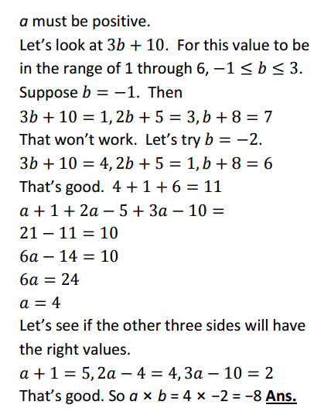

BCCTM 2015-16 Math Competition Solutions

Pre-Algebra 6/Grade 8 Individual

- D
- C
- B
- A
- D
- B
- D
- C
- C
- B
- A
- B
- D
- A
- C
- D
- B
- A
- B
- A
- A
- C
- D
- B
- B
- C
- C
- B
- D
- B

BCCTM 2015-16 Math Competition Solutions

Algebra 7/Algebra 8 Individual

- A
- D
- B
- B
- E
- B
- C
- A
- B
- C
- D
- B
- D
- B
- A
- A
- A
- D
- C
- C
- A
- D
- E
- B
- C
- C
- A
- A
- B
- B

BCCTM 2015-16 Math Competition Solutions

Geometry Individual

- C
- C
- B
- B
- D
- C
- A
- A
- B
- C
- B
- A
- D
- D
- C
- B
- A
- A
- D
- C
- D
- D
- C
- B
- A
- A
- A
- A
- B
- B

BCCTM 2015-16 Math Competition Solutions

Grade 6/Pre-Algebra 7 Team Solutions

Practice Question: 50 (Accept all answers for 4 points.)
- $-\frac{15}{14}$
- 3
- 6.5
- 900 ft²
- 44
- 1
- 18
- $44-4π$

Pre-Algebra 6/Grade 8 Team Solutions

Practice Question: 50
- 131
- 6 and 28 = 34
- 900
- $9.38
- 4
- 6
- x = 12
- Thursday

BCCTM 2015-16 Math Competition Solutions

Algebra7/Algebra 8 Team Solutions

Practice Question: 50 (Accept all answers for 4 points.)

- 24
- 4
- 2
- 72.5
- 4

Geometry Team Solutions

Practice Question: 50 (Accept all answers for 4 points.)

- 415
- 26
- $1152π$
- 12
- $4+2\sqrt{5}$
- $\frac{6-\sqrt{2}}{34}$
- SMILE
- $12+4\sqrt{3}$

Geometry 2015-16 Worked-out Solutions
- A and B are supplementary
21x − 9 = 180 21x = 189
x=9
m∠A = 31;m∠B =149;m∠C =164 The vertical angle of A, the supplement of C, and the vertical angle of D form a triangle, so A+D+(180-C)=180. D=C-A=164-31=133
m∠B + m∠C + m∠D − m∠A = 149 + 164 + 133 − 31 = 415 Answer: 415

- In order to make a triangle, the sum of any two sides must be greater than the third. Where x is the third side, 13+x is greater than 14 and x is less than 13+14, so x is an integer between 1 and 27 non-inclusive. The smallest possible side length is 2, and 142>132+22, so this side length creates an obtuse triangle. A= 2

To make a triangle, the third side length must be between 2 and 34 non-inclusive. To maximize the length of the third side and produce an acute triangle, the third side must be the longest in the triangle with the square of its length less than 162+182, which is 256+324=580. 24 is the greatest integer whose square is less than 580. B= 24

Answer: 26

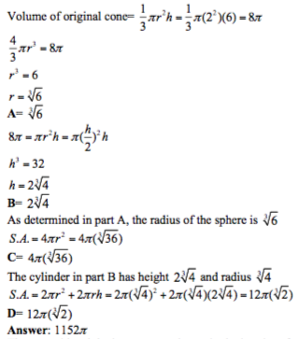

4.

(1) An undecagon is a polygon with eleven sides. True
(7) The distance between the centroid and a vertex of a triangle is 1/3 the length of the median from that vertex to the opposite side. False
(3) If drawing a diagonal in a quadrilateral creates two congruent triangles, the quadrilateral is a parallelogram False – an isosceles trapezoid would be divided into congruent triangles.
(4) A quadrilateral with two pairs of congruent sides is always a parallelogram False – a kite has two pairs of consecutive congruent sides
(6) If an altitude is drawn to the hypotenuse of a right triangle, the length of the altitude is the geometric mean of the segments of the hypotenuse True
(5) A triangle with side lengths 4, 5, and 8 is obtuse True – to be obtuse, a2 + b2 < c2 . 16 + 25 < 64 , so the triangle is obtuse.
Answer: 12

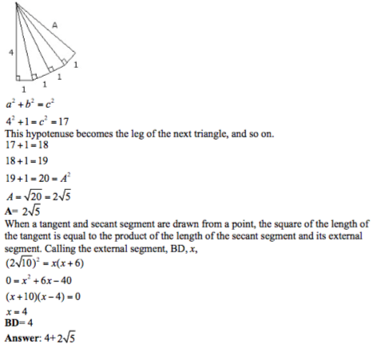

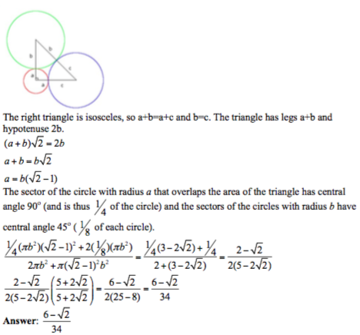

6.

- Regular polygon with four sides - Square
Point located halfway between two points - Midpoint
The intersection point of the angle bisectors - Incenter
Defined by two points - Line
The man considered to be the father of geometry – Euclid

Answer: smile

