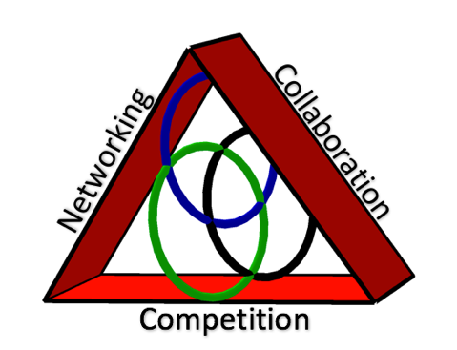**Broward County Council of Teachers of Mathematics**

**2016-2017**

**$150.00 Classroom Grant**

**Who May Apply:**

1. Any full time teacher certified in Broward County.
2. Applicants must be current members of BCCTM.
3. Applicants must have at least a Bachelor’s Degree.
4. Applicants must be involved in Mathematics Education
5. Application must be signed by your Principal/Supervisor.
6. List the Mathematics Professional Development courses you have taken in the past two years.
7. Explain in 250 words or less, what you will use the Classroom Grant for and how it will impact student achievement.

Applicant’s Name : ______________________________________ Email Address: __________________________

Current Teaching Assignment: _____________________________________ Grade: _______________________

School/Work Name: ________________________________________________________________________________

School/Work Address: _____________________________________________________________________________

School/Work Phone: _______________________________________________________________________________

Applications are due no later than October 15, 2016 to Nikole Palma @ [Nikole.sankey@browardschools.com](mailto:Nikole.sankey@browardschools.com) c/o Coral Springs HS 7201 W Sample Rd, Coral Springs, FL 33065, and will be accepted through the pony, mail, or scanned into an email.

As Principal/Supervisor, I support my employee’s application for a Classroom Grant from BCCTM.

Principal/Supervisor’s Signature: _______________________________________________________________

Applicant’s Signature: ___________________________________________________________________________________

___ _ I have never received a Grant from BCCTM. ____ I have received a Grant from BCCTM.

If you have previously received a grant, which one? _________________________ When? _______________

Timeline:

* Submit your grant application to Nikole Sankey Palma no later than October 14, 2016.
* You will be notified if your grant has been approved by November 4, 2016.
* Upon approval from BCCTM, purchase your materials and provide receipts to: Josianne Gourdet c/o Lloyd Estates Elementary School, 750 Northwest 41st Street, Oakland Park, FL 33309
* Grant Recipients will recognized at our annual Teacher of the Year Dinner in the spring at the Pine Island Ridge Country Club.