  - 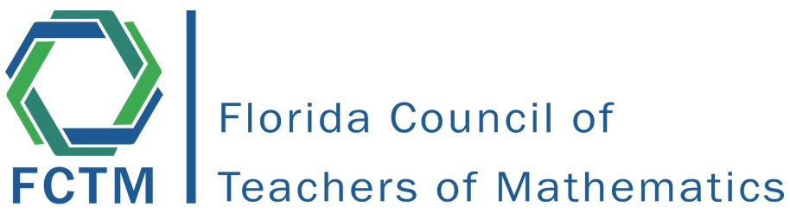

  - Annual Renee Henry
  - Leadership Conference

  - September 10-11, 2022
Hilton Altamonte Springs
350 Northlake Blvd, Altamonte Springs, FL 32701

This exciting program is designed with leaders in Florida math classrooms in mind. Along with networking with leaders across the state, enjoy professional development, updates Florida Department of Education & Test Development Center, and activities to help build Affiliate relationships.

To attend this conference you will need to be a current member of FCTM. Each affiliate group is eligible for reimbursement for travel expenses for one vehicle and one hotel room for Saturday night.

Cost: $5.00

To register visit
https://fctm.memberclicks.net/2022hrleadership

To register for a hotel room visit (One night per affiliate will be reimbursed)
https://www.hilton.com/en/attend-my-event/fctm1-09092022-09112022/

E-mail questions to
joseph.mcnaughton@polk-fl.net or rebecca_devor@scps.k12.fl.us

